CS 340 Project Two README

Neo Huynh

About the Project/Project Title
The purpose of the CRUD_Python_Module.py project is to have create, read, update, and delete functionality for the Austin Animal Center (aac) animal database. The purpose of the Project Two is to create a dashboard that provides the data of the database, creates a pie chart of the breeds, has a drop-down menu to select breeds from certain rescues, and pinpoints the exact location of where the animal is located using longitude and latitudes.

Motivation
The main motivation behind the creation and maintenance of the project is to learn and understand how Python can be used to interact with a MongoDB database as well as learn how HTML can interact to give a GUI for a database and its data. Creating such a database shows how to make a working and pleasant GUI for the user and how the Dash’s HTML interface can interact using Python to communicate with the database.

Getting Started
Ensure that your database is accessible and is already set up. In CRUD_Python_Module.py, there are configurable settings that require your username and password for the database. Change these to your desired information. Ensure that the CRUD_Python_Module.py file is somewhere accessible and useable. Ensure that in ProjectTwoDashboard.ipynb, the user and password of the database is also changed.

Installation
The main tools and libraries used for this project were MongoDB, Python, PyMongo, Dash, and Jupyter Labs. Jupyter Labs is not necessarily needed in for this project to work, just access to your database. You can find these libraries on their respective websites. The MongoDB Driver is primary chosen in the project because it allows Python code to directly connect to the MongoDB database and allows multiple MongoDB commands to be automated through Python. Dash was used to build the web application because it allows interactive dashboards to be created via Python instead of a separate JavaScript frontend. The controller uses callbacks that runs MongoDB queries through the CRUD_Python_Module.py file. This allows the dashboard to be interactive and update as so. These tools create code that is reusable and maintainable without having to alter the database repeatedly.

Usage
The ProjectTwoDashboard.ipynb file will return an app server from Dash link that leads to the webpage that contains the Dashboard. The dashboard contains a dropdown menu that contains four rescue types to select from, All, Water Rescue, Mountain/Wilderness Rescue, and Disaster rescue/Individual tracking. The dashboard also produces the animals preferred by population as a pie chart, which also reflects the animals being parsed with the dropdown menu. There is also a geolocation map that contains the longitude and latitude coordinates of the animals, as well as the name, breed, and Id of the animal.

Code Example
The main code of the project is the interactable components and how they parse the data. For example, this code creates the drop-down menu that filters the selections for the database to return:
html.Label('Select Rescue Type'),
dcc.Dropdown(
id='filter-type',
options = [
{'label' : 'All', 'value' : 'All'},
{'label' : 'Water Rescue', 'value' : 'Water'},
{'label' : 'Mountain or Wilderness Rescue', 'value' : 'Mountain'},
{'label' : 'Disaster or Individual Tracking', 'value' : 'Disaster'}
],
value='All'
)
In turn, this filter is used with the update_dashboard function that changes the listed animals using:
elif filter_type == 'Water':
query = {
'animal_type': 'Dog',
'$or': [
{"breed": {'$regex': re.compile(".*lab.*", re.IGNORECASE)}},
{"breed": {'$regex': re.compile(".*chesa.*", re.IGNORECASE)}},
{"breed": {'$regex': re.compile(".*newf.*", re.IGNORECASE)}},
],
'sex_upon_outcome': 'Intact Female',
'age_upon_outcome_in_weeks': {
'$gte': 26,
'$lte': 156
}
}

Which also updates the data used for the pie chart:
def update_graphs(viewData):
###FIX ME ####
# add code for chart of your choice (e.g. pie chart) #
if not viewData:
return html.P('No animals found')

dffPie = pd.DataFrame.from_dict(viewData)

df = (
dffPie['breed']
.fillna('unknown')
.value_counts()
.head(10)
.reset_index()
)

df.columns = ['Breed', 'Count']

return [
dcc.Graph(
figure = px.pie(df, names='Breed', values='Count', title='Preferred Animals') # returns the graph of breeds, with counts
)
]
And the map:
def update_map(viewData, index):
#FIXME Add in the code for your geolocation chart

if viewData is None or len(viewData) == 0: # returns nothing if there are no animals to display
return html.P(' No animals available to display')

dff = pd.DataFrame.from_dict(viewData)
if index is None or len(index) == 0: # would not create the map if the len(index) == 0, and caused an error where the children list index out of range
row = 0
else:
row = index[0]

animal = dff.iloc[row] # animal

latitude = pd.to_numeric(animal.get('location_lat'), errors="coerce") # pulled it out to make more managable, uses animal object to find location
longitude = pd.to_numeric(animal.get('location_long'), errors="coerce")

breed = animal.get('breed', 'Unknown breed') # finds the breed of the animal
animal_name = animal.get('name', '') # finds the name of the animal
animal_id = animal.get('animal_id', 'Unknown ID') # finds the ID of the animal

if pd.isna(latitude) or pd.isna(longitude):
return html.P("The selected animal has no valid coordinates")

if pd.isna(animal_name) or not str(animal_name).strip():
animal_name = animal_id # In Module Six, I had it return nothing if there was no animal name. Probably better to just default to ID for identification purposes

return [
dl.Map(
style={"width": "1000px", "height": "500px"}, # from the post
center=[latitude, longitude], # goes to direct location of animal, better in general
zoom=10,
children=[
dl.TileLayer(id="base-layer-id"),

dl.Marker(
position=[latitude, longitude], # works similarily
children=[
dl.Tooltip(str(breed)),
dl.Popup([
html.H3(str(animal_name)), # returns animal name (id if there is no possible name)
html.P('Breed: ' + str(breed)),
html.P('Animal ID:' + str(animal_id))
])
])
])
]

Tests
Unlike Project One, there is no test script that tests the main files. Instead, the ProjectTwoDashboard.ipynb file works as a webpage and thus can be tested and reviewed for any errors. This also tests the CRUD_Python_Module.py file with any read, but not any create, update, or delete functions.

Challenges
There have been a few challenges that I faced when creating this dashboard for this project, such as getting the database to work in full of the dashboard or filtering queries based on the names. When I was working with the database, I accidentally used the Delete function in my CRUD to remove all the dogs in a prior week. This meant that I had to find out why none of the drop-down menus had returned any animals and why that was not working. Due to that issue, I realized that my code that returned the animals based on their names could be bad because some of the animals had messy breed names/data and thus was not returning everything necessary. I found that regex is perfect for parsing the data and thus used $or to find and return the correct information. This also meant that I did not see that the dogs were removed from the database and thus meant I had messed up something again. I had found by querying my database that I had removed all animals of animal_type: ‘dog’ and found why all my animals were returning nothing from the drop-down menu. I decided that I would remove the animals from my database and repopulate them using MongoDB and fix my problems.

Screenshots
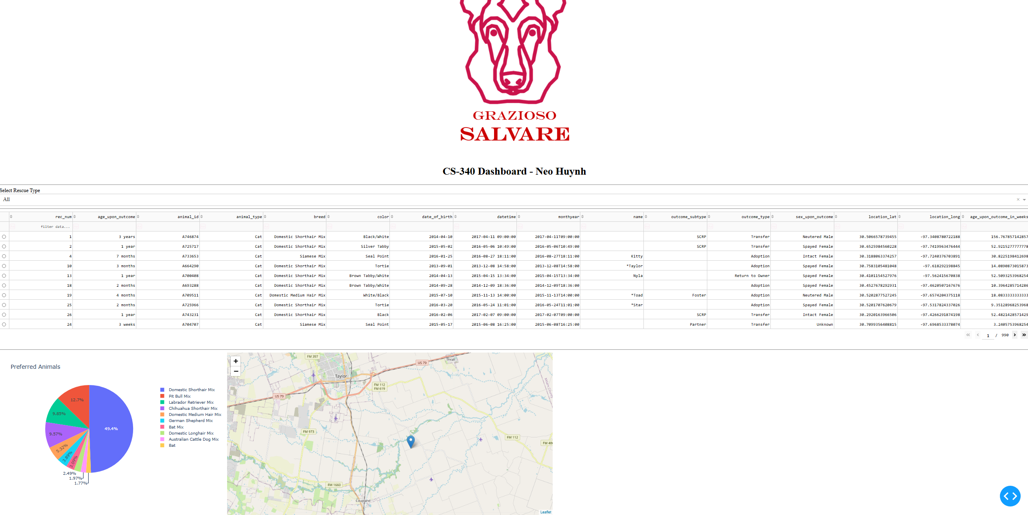
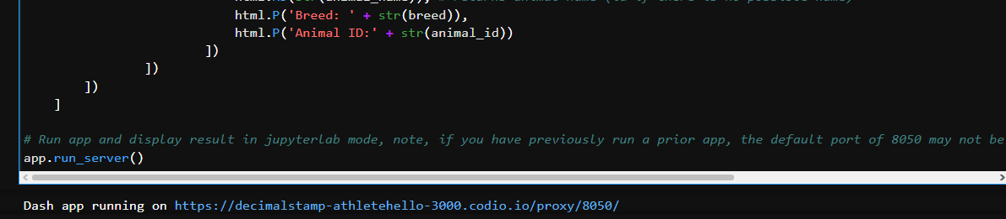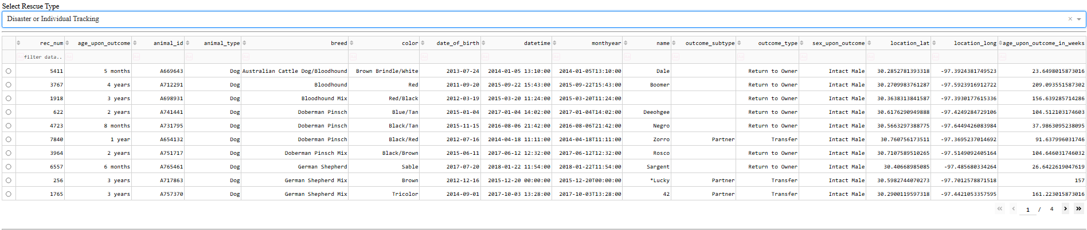
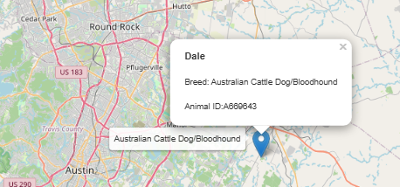

Links:
https://www.mongodb.com/
https://www.mongodb.com/docs/languages/python/pymongo-driver/current/
https://dash.plotly.com/
https://jupyter.org/

Contact
Neo Huynh
Neo.huynh@snhu.edu

